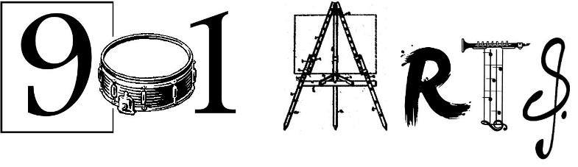
Volunteer Form
(please fill out and return with your resume and a short bio)

Name: ________________________________________________________________________

Current Address: _______________________________________________________________

Permanent Address: ____________________________________________________________

Date of Birth: ____________ University/College (if currently enrolled): ___________________

Gender Pronoun (circle): He/Him/His She/Her/Hers They/Them Other:___________

Title/Honorific (circle): Mr. Mrs. Ms. Mx. Other:________

Phone: ___________________________ Email: ____________________________________

Emergency Contact (name, phone, relationship): _____________________________________

______________________________________________________________________________

Allergies? YES__ NO___ If yes describe? _____________________________________

Reasonable Accommodations: ___________________________________________________

How did you hear about 901 Arts: _________________________________________________

______________________________________________________________________________

In a few sentences please explain your interest in volunteering at 901 Arts: ______________

______________________________________________________________________________

______________________________________________________________________________

Which volunteer role(s) are you interested in? (check all that apply): Art Class assistant___

Music/Singing Tutor ___ (Instrument: ___________________) Administrative Assistant_____

One-time events (chaperoning field trips/drumline performances) ____ Fundraising ___

Tabling at Markets/Fairs/Events (to assist youth in selling their artwork) ____

Special Project please describe: ________________________________________

______________________________________________________________________________

Do you have other skills you would like to share? ___________________________________

References (Professional or Academic, non family members):

1. Name: ____________________________ Title: ____________________________

Phone: ____________________________ Email: ____________________________

Your connection: ________________________________________________________

2. Name: ____________________________ Title: ____________________________

Phone: ____________________________ Email: ____________________________

Your connection: ________________________________________________________

Background Checks: In the state of Maryland it is required for any adult working with vulnerable populations to be fingerprinted and background checked. If you have had this done in the state of Maryland within the last year, please provide us with a copy of your records. If not, please get a one sheet from us with directions on how to do this.

901 Swag: We have a limited number of items, hand silk screened by teens at 901 Arts. If you are interested in making a donation for any of the items below we would be delighted to let you know what we have in stock.
*White 100% cotton T-shirt with 901 Logo in black ink $12-$15 sliding scale. Shirt Size________
* Tote bags in a variety of colors with 901 logo in black or white ink. Medium $4 __ Large $5___
* 100% cotton drawstring back pack variety of colors with 901 logo in black or white $6 ______
*CD of 901 Arts drumline performing live and bonus tracks of youth singers and pianist $5 ____

------------------------------------------------------------------------------------------------------------------------------------------------------
For office use only:

Interview:____ Bio:___ Orientation Date: ____ Mailing List:___
Finger printing:___ ID: ______ Start Date: ______ Mailchimp: ____ Background check:___ Resume:___ Total hours: _______ Volunteer Database:___

